Website policy

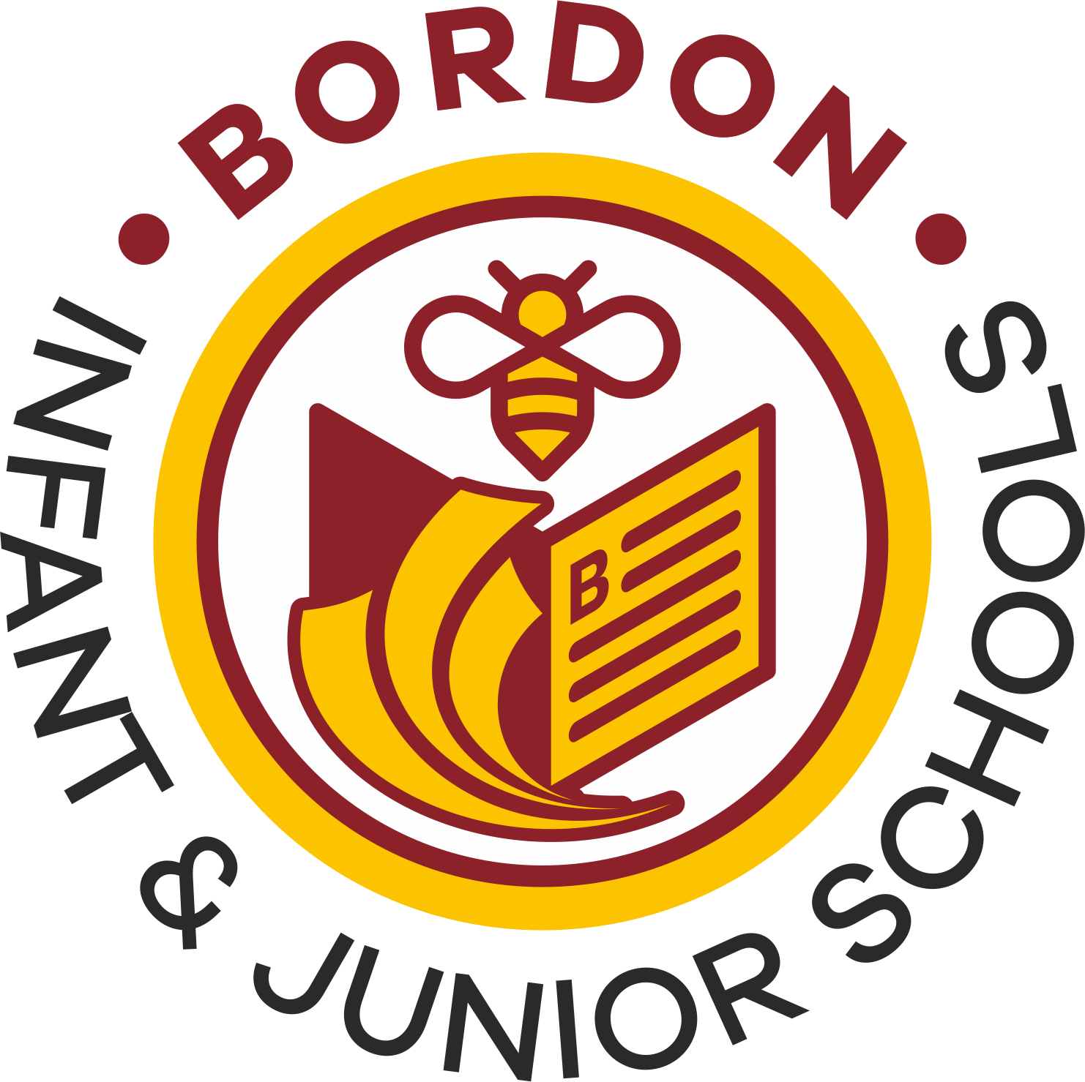

Bordon Infant and Junior School
Uniform Policy

Published June 2026
To be reviewed by June 2029
Then every three years

Bordon Infant and Junior School Uniform Policy

At Bordon Infant and Junior Schools we value school uniform as we believe it helps children feel a sense of belonging to a community and a sense of pride in themselves and their school. We believe that all children wearing the school uniform helps to create an atmosphere of learning and instil in the children a culture of coming to school to do their very best in everything they do.

Cost principles
We believe that school uniform should not place a financial burden on any parent. To support this, we: -
- Sell branded uniform at cost and ensure we achieve the best price possible from our suppliers
- Ensure all our uniform is readily available un-branded from a range of supermarkets and other retail outlets
- Encourage parents to donate good quality unwanted uniform which the parent’s association sell for a minimal cost or let parents swap items for a larger/smaller size

Our school uniform is:

Black or grey trousers, shorts, skirts or pinafores
White polo shirt
burgundy jumper
burgundy cardigan

Black smart school shoes;
- Appropriate for both indoor and outside play, including running and climbing
- No boots, as children find it uncomfortable sitting cross legged

Infants only | Juniors only
White polo shirt  Burgandy checked dresses | Blue polo shirt  Blur checked dresses

Hair accessories should be in the school colours. They should be simple, smart and in keeping with the ethos of this policy. The school colours are;
- Burgundy
- White
- Grey
- Black

If children have their ears pierced then they should wear studs only.
- If children have any other type of earing we will ask parents or the child to remove them

PE Kit
Burgandy PE top with the school logo
Plain black shorts
Sports trainers or black plimsolls
Burgundy hooded jumper
Black jogging bottoms

Items that are available to purchase from the school uniform supplier with embroidered school logos are;
White polo shirt
Burgundy jumper
Burgundy cardigan
Waterproof burgundy coats
Burgundy book bag
Burgundy PE bag

https://www.schooltrends.co.uk/collections/bordoninfantschoolgu350jb

