Writing Non-Negotiables
Year 3

To be a successful writer, these things need to be correct in my writing.
 | Capital letters
 | Full stops
 | Question marks
 | Red words
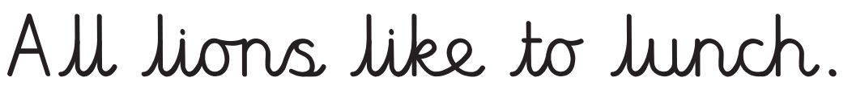 | Letter joins

Writing Non-Negotiables
Year 4

To be a successful writer, these things need to be correct in my writing.
 | Basic punctuation
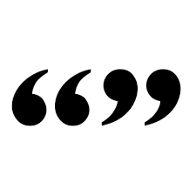 | Inverted commas
 | Exclamation marks
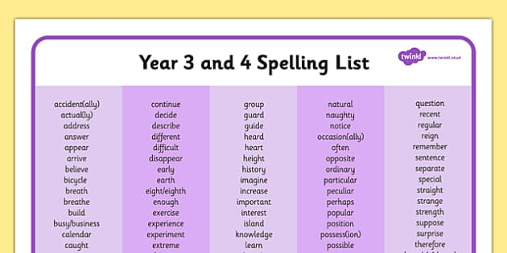 | Year 3 and 4 spelling words (as well as red words)
 | Letter joins

Writing Non-Negotiables
Year 5

To be a successful writer, these things need to be correct in my writing.
 | Basic punctuation
 | Commas
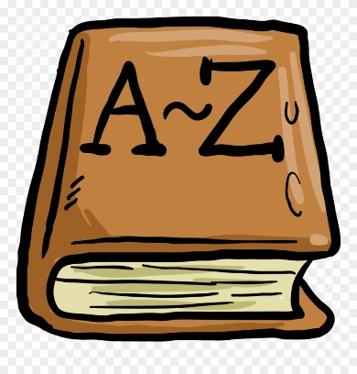 | Words from the class dictionary (as well as red words and words from the year 3 and 4 spelling list)

Writing Non-Negotiables
Year 6

To be a successful writer, these things need to be correct in my writing.

 | Basic punctuation
 | Apostrophes
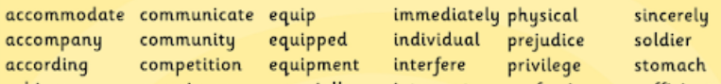 | Year 5 and 6 spelling words (as well as red words and words from the year 3 and 4 spelling list)

